Practice 4

Tyler Gillette

**Chapter 7, pages 363: problem 4**

Given the following mix of tasks, task lengths, and arrival times, compute the completion and response time for each task, along with the average response time for the FIFO, RR, and SJF algorithms. Assume a time slice of 10 milliseconds and that all times are in milliseconds.

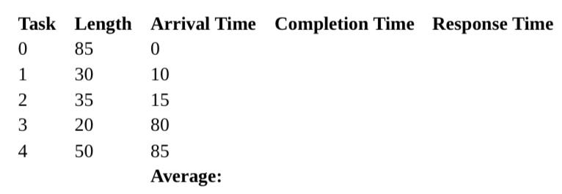

FIFO:

Comp Time: 220 ms

Avg Resp: 82.5 ms

RR: (Slice = 10ms)

Comp Time: 205 ms

Avg Resp: 6.6 ms

SJF:

Comp Time: 410 ms

Avg Resp: 57.5 ms

**Chapter 7, page 364: problem 8**

If a queueing system with one server has a workload of 1000 tasks arriving per second, and the average number of tasks waiting or getting service is 5, what is the average response time per task?

1000/5 = 200 ms per task.

**Chapter 7, page 364-365: problem 13, part ©**

Three tasks, A, B, and C are run concurrently on a computer system. Task A arrives first at time 0 and uses the CPU for 100 ms before finishing. Task B arrives shortly after A, still at time 0. Task B loops ten times; for each iteration of the loop, B uses the CPU for 2 ms and then it does I/O for 8 ms. Task C is identical to B, but arrives shortly after B, still at time 0. Assuming there is no overhead to doing a context switch, identify when A, B and C will finish for each of the following CPU scheduling disciplines:

a. FIFO ([100ms] 100ms)

b. Round robin with a 1 ms time slice ([2ms] 8ms [90ms] 292ms)

c. Round robin with a 100ms time slice ([100ms] 202ms [3)

d. Multilevel feedback with four levels, and a time slice for the highest priority level is 1ms.

e. Shortest job first